“APTECH GARDEN COMPUTER EDUCATION”
(PROJECT )

TOPIC NAME : PHP - COVID TEST and VACCINATION System

MEMEBERS

ENROLMENT ID NAME_____
Student1685038 | MUHAMMAD OWAIS
Student1684273 | MUHAMMAD HAMMAD
Student1687645 | MUHAMMAD HAMAYL
Student1693664 | HUNAIN

SR:NO | TOPICS | Pg:no
01 | Introduction  HEADER
02 | LOGO AND NAME : Covid Care | 1
03 | Features | 2
04 | For You | 3
05 | Stats | 4
06 | Contact | 5
07 | Developers | 6
08 | Sign In | 7
09 | Get Started | 8

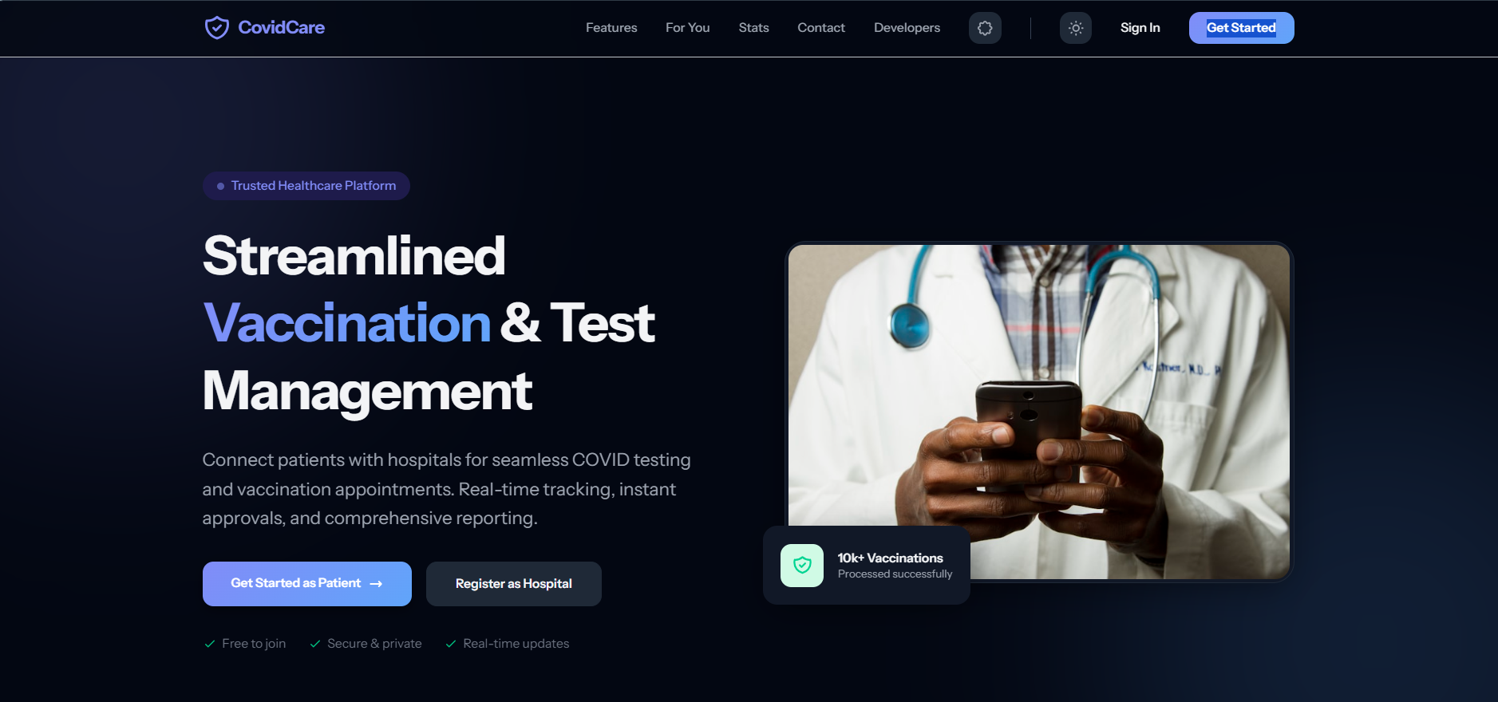

Header Section
The Header is the top navigation area of the CovidCare website. It is designed with a modern dark theme and provides users with quick access to the main sections of the application.
The left side of the header displays the CovidCare logo, which represents the platform's identity and branding. The center contains the main navigation menu with links such as Features, For You, Stats, Contact, and Developers, allowing users to navigate easily throughout the website.
On the right side, the header includes a Theme Toggle option for switching between light and dark modes, a Sign In button for existing users, and a prominent Get Started button that directs new users to the registration process.
Overall, the header offers a clean, user-friendly, and responsive navigation experience that enhances accessibility and improves the overall user interface.

Hero Section
The Hero Section is the first and most important section of the homepage. Its purpose is to immediately inform visitors about the main objective of the CovidCare platform.
At the top of the hero section, a "Trusted Healthcare Platform" badge builds credibility and assures users that the platform is reliable. The main heading, "Streamlined Vaccination & Test Management," clearly communicates that the system is designed to simplify COVID-19 vaccination and testing services.
Below the heading, a short description explains that the platform connects patients with hospitals for online COVID-19 test and vaccination appointments. It also highlights key features such as real-time appointment tracking, instant approvals, and comprehensive reporting, making the healthcare process more efficient and convenient.
The section contains two primary Call-to-Action (CTA) buttons:
- Get Started as Patient – Allows patients to register and book COVID-19 tests or vaccination appointments.
- Register as Hospital – Enables hospitals to register and manage patient appointments through the platform.
Below the buttons, three important platform benefits are displayed:
- Free to Join – Users can register without any registration fee.
- Secure & Private – User data is protected with secure authentication and privacy measures.
- Real-Time Updates – Patients receive instant notifications and live status updates regarding their appointments.
On the right side of the hero section, a professional healthcare image of a doctor represents medical services and builds user trust. A floating information card displaying "10k+ Vaccinations Processed Successfully" serves as social proof, demonstrating the platform's reliability and successful service record.
Overall, the Hero Section effectively introduces the CovidCare platform, highlights its core features, encourages user registration, and creates a trustworthy first impression through a clean and modern design

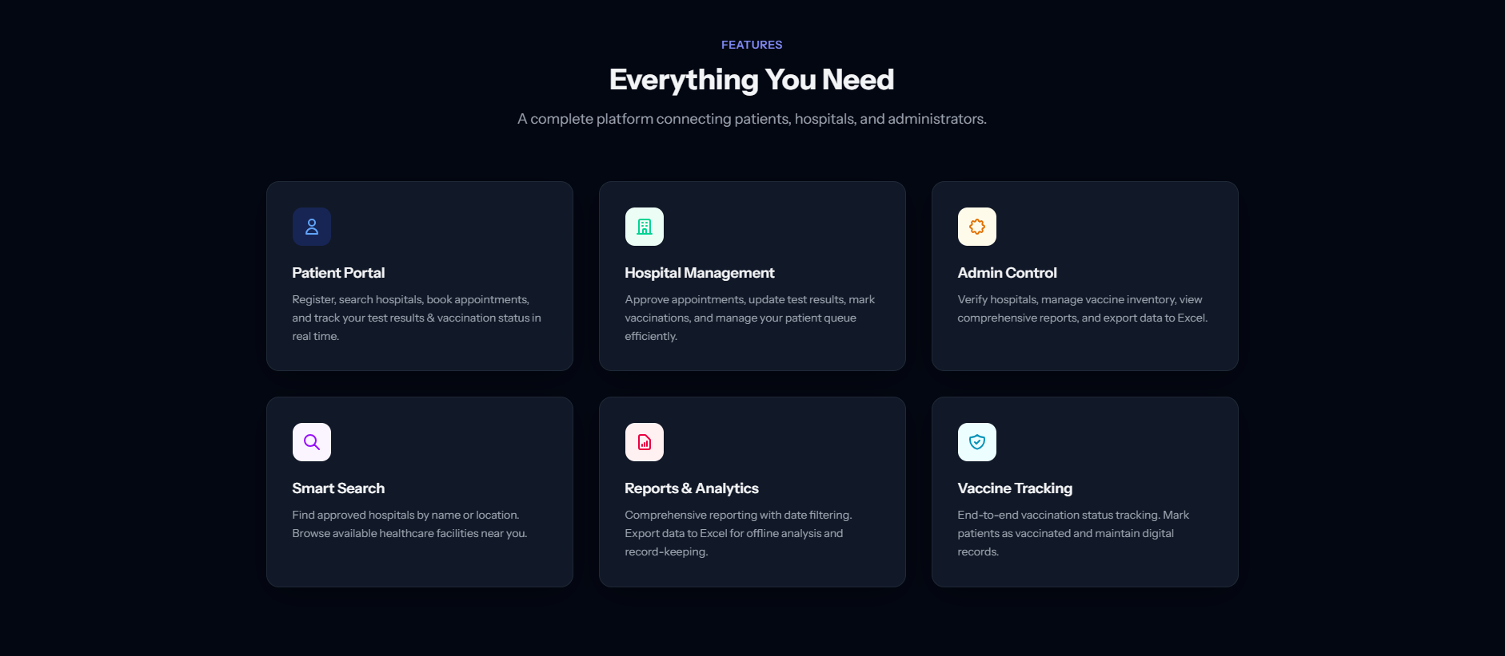

Features Section
The Features Section highlights the core functionalities of the CovidCare platform. It provides an overview of the main services available to patients, hospitals, and administrators, demonstrating how the system simplifies the COVID-19 testing and vaccination process. The features are presented in a clean card-based layout, making the information easy to understand and visually appealing.

1. Patient Portal
The Patient Portal enables users to create an account, search for approved hospitals, book COVID-19 test or vaccination appointments, and monitor their appointment status. Patients can also track their test results and vaccination records in real time through a secure and user-friendly dashboard.

2. Hospital Management
The Hospital Management module allows registered hospitals to efficiently manage patient appointments and healthcare services. Hospital staff can approve or reject appointment requests, upload COVID-19 test results, update vaccination records, and organize patient queues, ensuring smooth and effective healthcare operations.

3. Admin Control
The Admin Control module provides complete administrative authority over the platform. Administrators can verify hospital registrations, manage vaccine inventory, monitor system activities, generate reports, and export important data to Excel for record-keeping and further analysis. This module ensures that the platform operates securely and efficiently.

4. Smart Search
The Smart Search feature helps patients quickly locate approved hospitals based on their name or location. It improves accessibility by allowing users to find nearby healthcare facilities and compare available services before booking an appointment.

5. Reports & Analytics
The Reports & Analytics module enables administrators to generate comprehensive reports related to appointments, COVID-19 tests, vaccinations, and hospital performance. Reports can be filtered by date and exported to Excel, supporting effective decision-making and maintaining accurate records.

6. Vaccine Tracking
The Vaccine Tracking feature maintains complete digital records of each patient's vaccination status. It allows hospitals to update vaccination progress and enables patients to view their vaccination history, ensuring accurate record management and real-time status tracking.

Overall Summary
The Features Section demonstrates that the CovidCare platform is designed to serve three major user roles—Patients, Hospitals, and Administrators. By integrating appointment booking, hospital management, vaccine tracking, smart search, and reporting into a single platform, the system provides a secure, efficient, and user-friendly solution for managing COVID-19 testing and vaccination services.

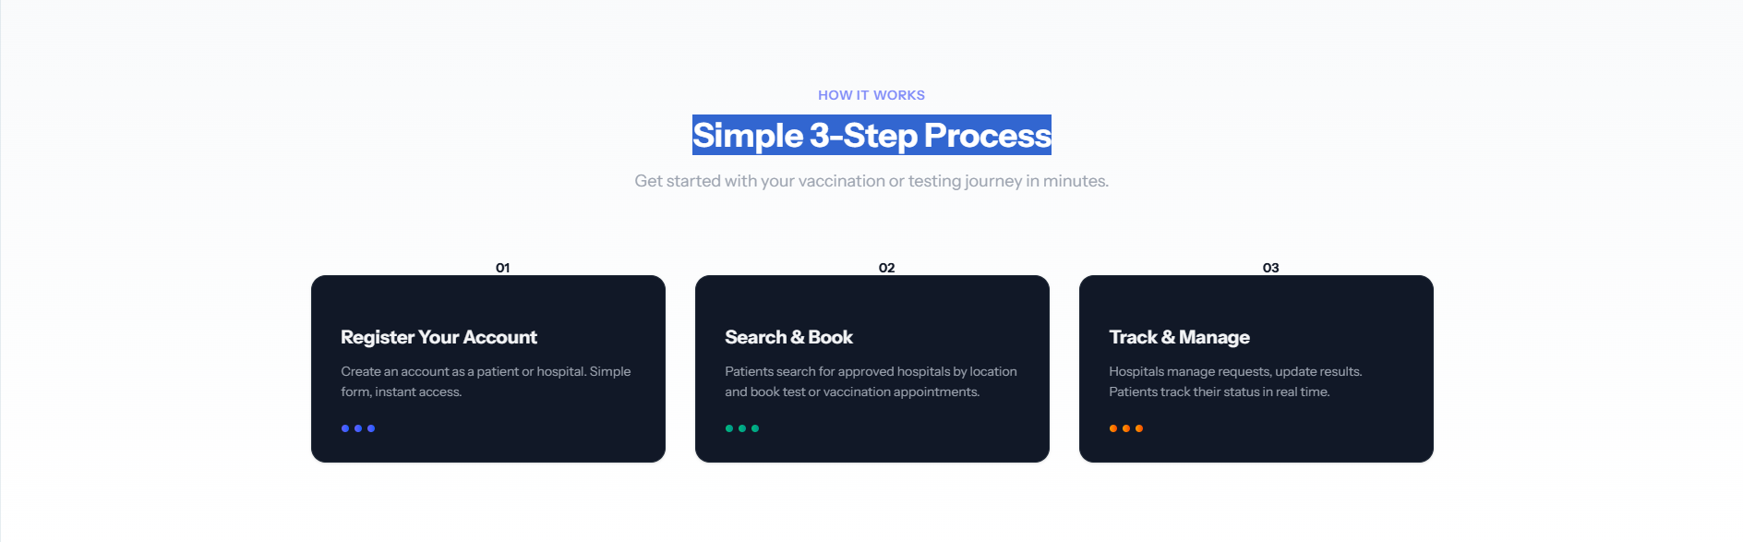

How It Works Section
The How It Works Section explains the complete workflow of the CovidCare platform in three simple steps. This section is designed to help users quickly understand how they can register, book appointments, and manage their COVID-19 testing or vaccination process. By presenting the workflow in a clear and structured manner, the platform ensures a smooth and user-friendly experience for both patients and hospitals.

Step 1: Register Your Account
The first step is to create an account on the platform. Users can register either as a Patient or a Hospital by filling out a simple registration form. Once the registration process is completed, users gain instant access to the system and its available services.

Step 2: Search & Book
After registration, patients can search for approved hospitals using the platform’s search functionality. They can view available healthcare facilities and book COVID-19 test or vaccination appointments according to their requirements. This process eliminates the need for manual visits and simplifies appointment scheduling.

Step 3: Track & Manage
The final step allows users to manage and monitor their appointments. Hospitals can review requests, update test results, and record vaccination statuses. Patients can track the progress of their appointments and view real-time updates regarding their tests and vaccinations through their dashboard.
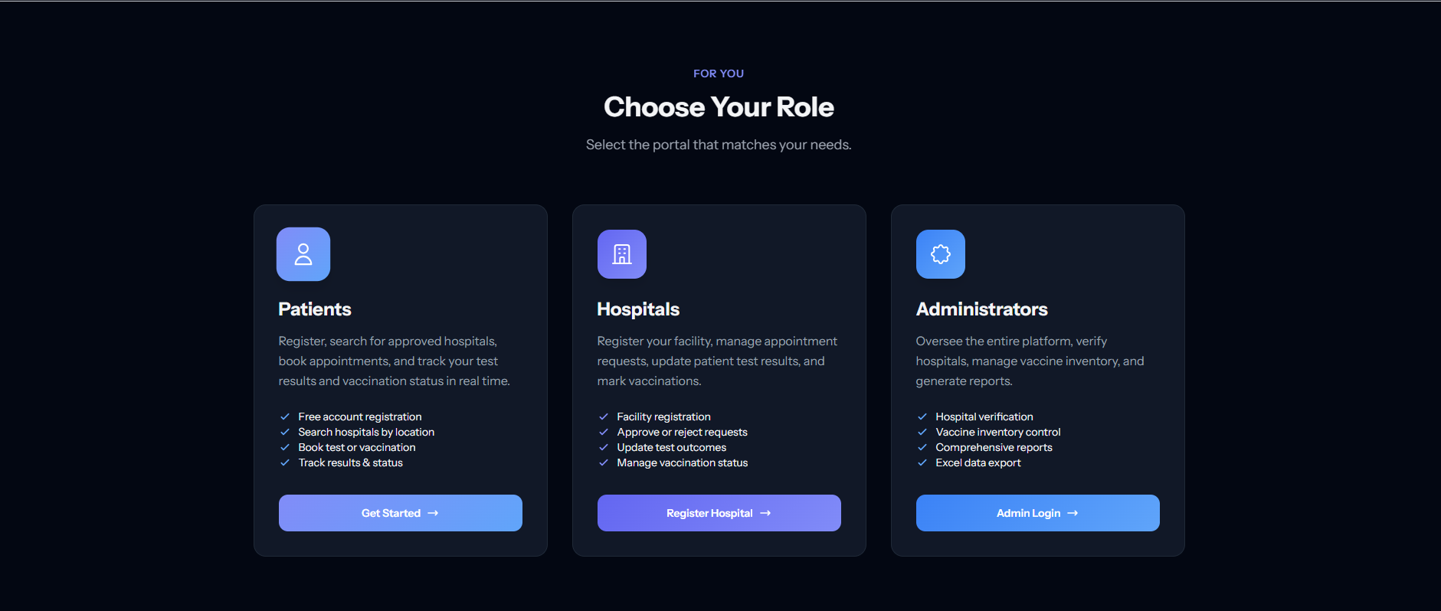

Role Selection Section (Choose Your Role)
The Role Selection section allows users to choose the portal that matches their role within the CovidCare system. Since the platform serves multiple types of users, this section provides separate access points for Patients, Hospitals, and Administrators. Each role has its own dashboard, features, and responsibilities, ensuring a secure and organized user experience.

1. Patient Portal
The Patient portal is designed for individuals who want to book COVID-19 tests or vaccination appointments. Patients can create a free account, search for approved hospitals, schedule appointments, and monitor their test results and vaccination status in real time.
Key Features:
- Free account registration
- Search hospitals by location
- Book COVID-19 test or vaccination appointments
- Track test results and vaccination status
The "Get Started" button redirects users to the patient registration or login page.

2. Hospital Portal
The Hospital portal is intended for healthcare facilities that provide COVID-19 testing and vaccination services. Hospitals can register their facilities, manage appointment requests, update patient test results, and maintain vaccination records through a dedicated dashboard.
Key Features:
- Hospital registration
- Approve or reject appointment requests
- Update COVID-19 test results
- Manage patient vaccination records
The "Register Hospital" button allows hospitals to create an account and access the hospital management dashboard.

3. Administrator Portal
The Administrator portal provides complete control over the CovidCare platform. Administrators are responsible for verifying hospital registrations, managing vaccine inventory, monitoring overall system activities, and generating reports for analysis and record management.
Key Features:
- Hospital verification and approval
- Vaccine inventory management
- Comprehensive reporting and analytics
- Export reports to Excel
The "Admin Login" button allows authorized administrators to securely access the administrative dashboard.
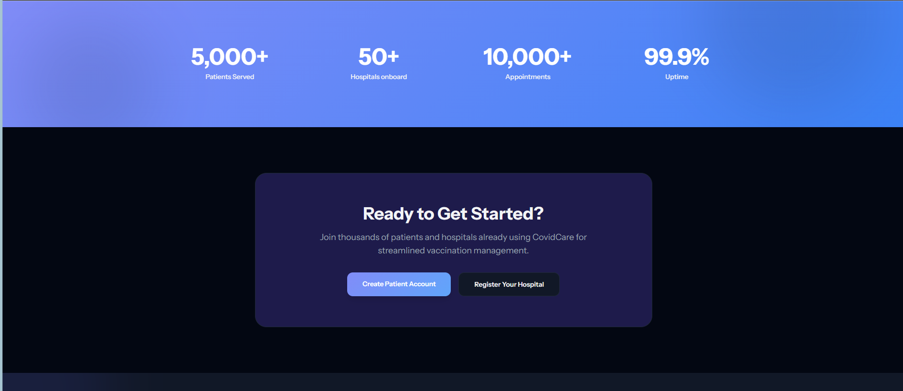

Statistics Section
The Statistics Section presents key performance indicators (KPIs) of the CovidCare platform. It highlights the platform's growth, reliability, and overall performance by displaying important statistical information in a visually attractive layout.
The statistics shown include:
- 5,000+ Patients Served – Indicates the number of patients who have successfully used the platform for COVID-19 testing and vaccination services.
- 50+ Hospitals Onboard – Represents the number of registered and verified hospitals providing healthcare services through the platform.
- 10,000+ Appointments – Shows the total number of COVID-19 test and vaccination appointments processed by the system.
- 99.9% Uptime – Demonstrates the reliability and availability of the platform, ensuring uninterrupted access for users.
The purpose of this section is to build trust and confidence by showcasing the platform's achievements and operational success.

Call-to-Action (CTA) Section
The Call-to-Action (CTA) Section encourages visitors to become part of the CovidCare platform. It serves as the final invitation for users to register and start using the system.
The section features the heading "Ready to Get Started?", followed by a short description inviting patients and hospitals to join the platform for a faster and more efficient COVID-19 vaccination and testing experience.
Two action buttons are provided:

1. Create Patient Account
The Create Patient Account button redirects new patients to the registration page, where they can create an account, search for hospitals, book appointments, and track their vaccination or test status.

2. Register Your Hospital
The Register Your Hospital button allows healthcare organizations to register their facilities on the platform. After registration and verification, hospitals can manage appointments, update patient records, and provide COVID-19 healthcare services.
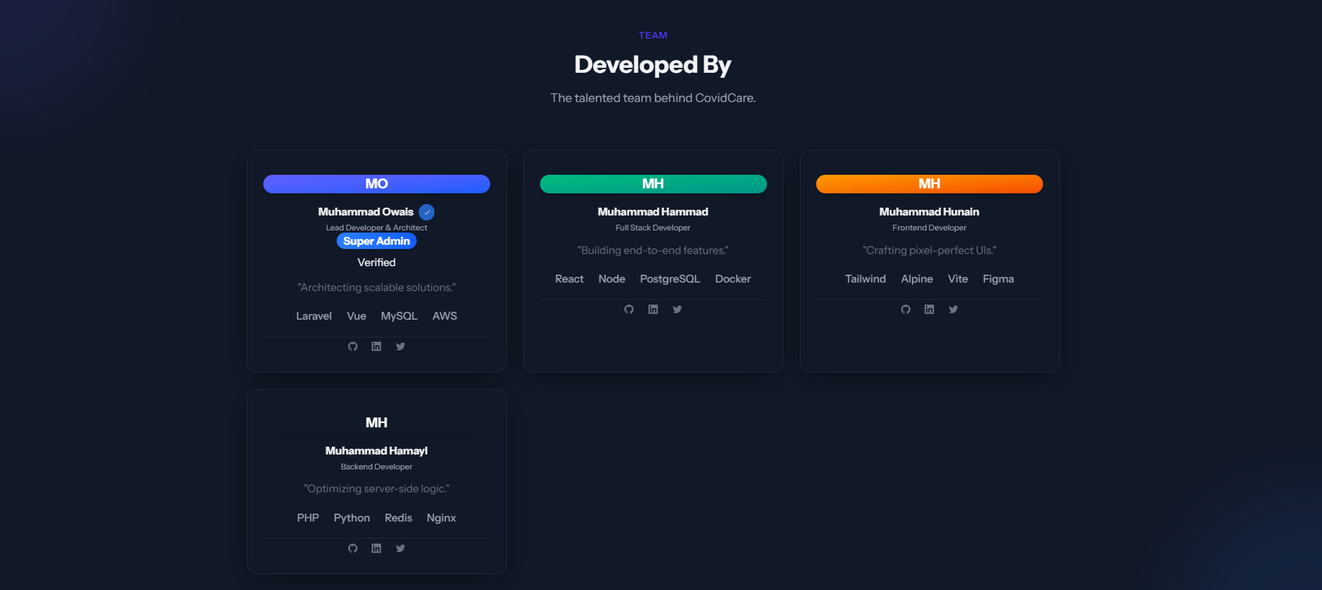

Team Section (Developed By)
The Team Section introduces the developers responsible for designing and developing the CovidCare platform. It highlights the team members, their roles, technical expertise, and responsibilities within the project. This section recognizes the contribution of each developer and provides transparency about the development team behind the system.
Each team member is presented in a separate profile card containing their name, role, technical skills, and social media links. The card-based layout creates a professional appearance and allows visitors to easily understand the responsibilities of each developer.

1. Super Admin / Lead Developer
The Lead Developer is responsible for planning the overall architecture of the system and managing the development process. This role oversees project implementation, database design, system integration, and ensures that all modules work together efficiently.
Responsibilities:
- Design the overall system architecture
- Manage backend and frontend integration
- Supervise project development
- Ensure system scalability and performance

2. Full Stack Developer
The Full Stack Developer is responsible for developing both the frontend and backend components of the application. This role implements core features, integrates the database, and ensures smooth communication between the user interface and server.
Responsibilities:
- Develop frontend and backend modules
- Implement business logic
- Integrate database functionality
- Build complete application features

3. Frontend Developer
The Frontend Developer focuses on designing the user interface and improving the user experience. This role creates responsive web pages, modern layouts, and interactive components to ensure that the platform is visually appealing and easy to use.
Responsibilities:
- Design responsive user interfaces
- Improve user experience (UX)
- Develop interactive web components
- Maintain consistent visual design

4. Backend Developer
The Backend Developer is responsible for implementing server-side functionality, database operations, and application security. This role ensures that all user requests are processed correctly and that the platform performs efficiently.
Responsibilities:
- Develop server-side logic
- Manage databases and APIs
- Implement authentication and security
- Optimize system performance
==================================================================
Footer


Footer Section
The Footer Section is the final part of the CovidCare website and provides users with important navigation links, registration options, and contact information. It serves as a central location for accessing essential pages while maintaining a clean and professional layout.
The footer is divided into four main columns, making the information well-organized and easy to navigate.

1. Brand Information
The first column displays the CovidCare logo along with a short description of the platform. It briefly explains that CovidCare is a healthcare management system designed to connect patients with hospitals for online COVID-19 testing and vaccination services. This section reinforces the platform's identity and purpose.

2. Quick Links
The Quick Links section provides direct access to the main login portals of the system. Users can quickly navigate to:
- Patient Login
- Hospital Login
- Admin Login
These shortcuts improve accessibility by allowing users to reach their respective dashboards without navigating through multiple pages.

3. Registration
The Registration section contains links for new users who wish to join the platform. It includes:
- Register as Patient
- Register as Hospital
These options enable both patients and healthcare facilities to create accounts and start using the CovidCare system.

4. Contact Information
The Contact section provides essential support details for users who need assistance. It includes:
- Official support email address
- Customer support helpline
- 24/7 support availability
This ensures that users can easily contact the support team whenever they require technical or service-related assistance.

Copyright Notice
At the bottom of the footer, a Copyright Notice is displayed:
© 2026 CovidCare System. All Rights Reserved.
This statement indicates that all content, design, and intellectual property of the CovidCare platform are legally protected and reserved by the project owners.
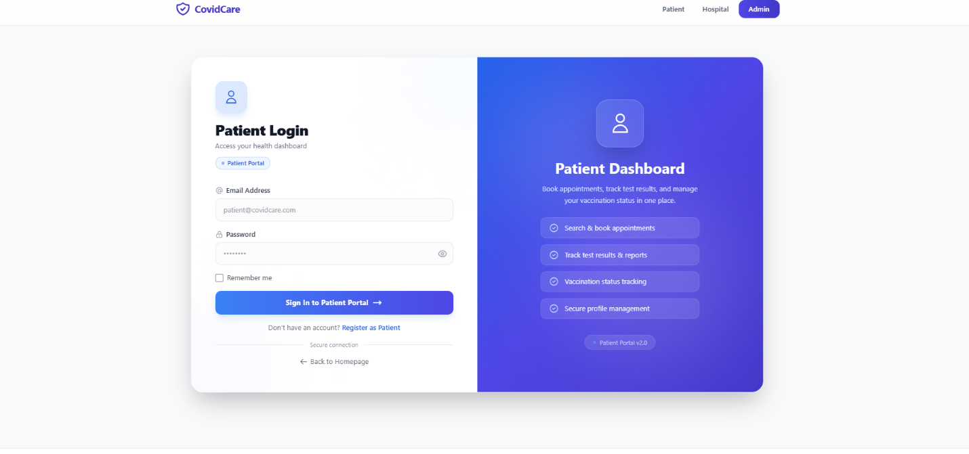

Patient Login Page
The Patient Login Page allows registered patients to securely access their personal dashboard. It is designed with a modern two-column layout that combines a user-friendly login form with an informative panel highlighting the key features available to patients after login.
The page ensures secure authentication while providing a clean, responsive, and visually appealing interface.

Login Form
The left side of the page contains the Patient Login Form, where registered users enter their credentials to access the system.
The form includes the following fields:
- Email Address – Allows the patient to enter their registered email address.
- Password – Allows the patient to enter their secure password.
- Remember Me – Keeps the user logged in on the current device for future visits.
- Sign In to Patient Portal – Authenticates the user's credentials and redirects them to the Patient Dashboard.
- Register as Patient – Provides a link for new users who do not already have an account.
- Back to Homepage – Allows users to return to the website's homepage.
- Secure Connection – Indicates that the login process is protected to ensure user privacy and data security.

Patient Dashboard Preview
The right side of the page displays an overview of the Patient Dashboard, giving users an idea of the services they can access after successfully logging in.
The dashboard provides the following features:
- Search and book COVID-19 test or vaccination appointments.
- Track COVID-19 test results and medical reports.
- Monitor vaccination status in real time.
- Manage personal profile information securely.
This preview helps users understand the functionality of the patient portal before accessing their dashboard.

User Interface Design
The login page uses a modern card-based design with a blue and purple gradient theme, rounded corners, and responsive components. The layout is optimized for desktops, tablets, and mobile devices, ensuring a consistent and user-friendly experience across different screen sizes.
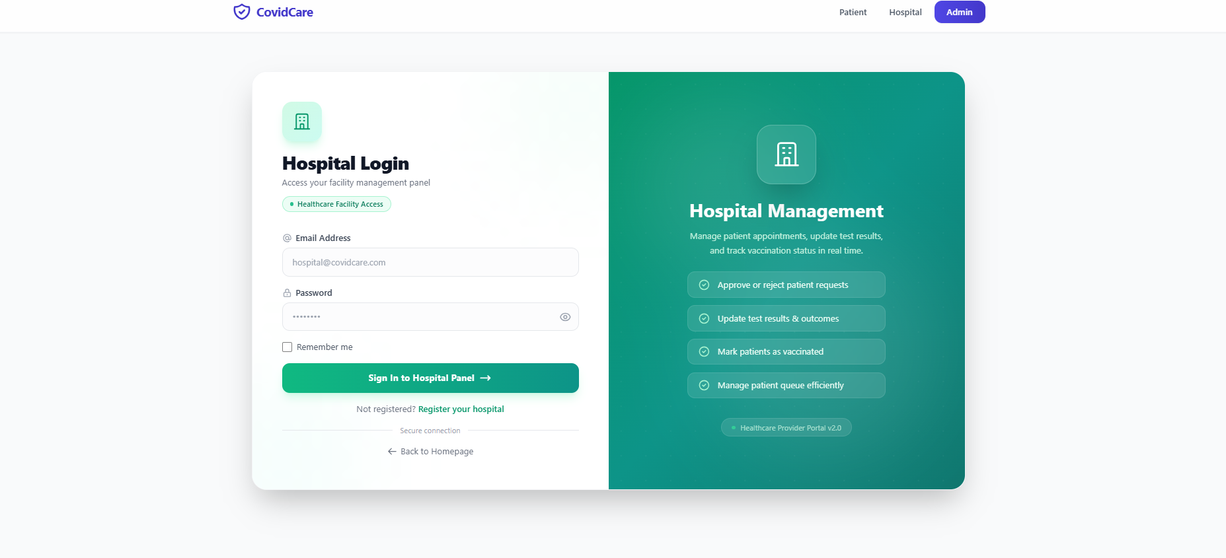

Hospital Login Page
The Hospital Login Page allows registered hospitals and healthcare providers to securely access their management dashboard. It is designed with a modern two-column layout that combines a secure login form with an overview of the hospital management features available after authentication.
The page provides a simple, responsive, and secure interface for hospital staff to manage COVID-19 testing and vaccination services efficiently.

Login Form
The left side of the page contains the Hospital Login Form, where authorized healthcare providers enter their login credentials.
The form includes the following components:
- Email Address – Allows the hospital to enter its registered email address.
- Password – Allows authorized staff to enter their secure password.
- Remember Me – Keeps the user logged in on the current device for future sessions.
- Sign In to Hospital Panel – Authenticates the user's credentials and redirects them to the Hospital Dashboard.
- Register Your Hospital – Provides a registration link for new healthcare facilities that are not yet registered.
- Back to Homepage – Redirects users to the main homepage.
- Secure Connection – Indicates that the authentication process is protected to ensure secure access and data privacy.

Hospital Management Preview
The right side of the page displays a preview of the Hospital Management Dashboard, highlighting the core services available after login.
The dashboard enables hospitals to:
- Approve or reject patient appointment requests.
- Update COVID-19 test results and patient outcomes.
- Mark patients as vaccinated.
- Manage patient queues efficiently.
- Monitor vaccination status in real time.
This preview gives healthcare providers a clear understanding of the system's functionality before they access the dashboard.

User Interface Design
The Hospital Login Page features a modern card-based interface with a green gradient theme representing healthcare and medical services. The responsive layout, rounded components, and clean typography provide a professional appearance and ensure a smooth user experience across desktop, tablet, and mobile devices.
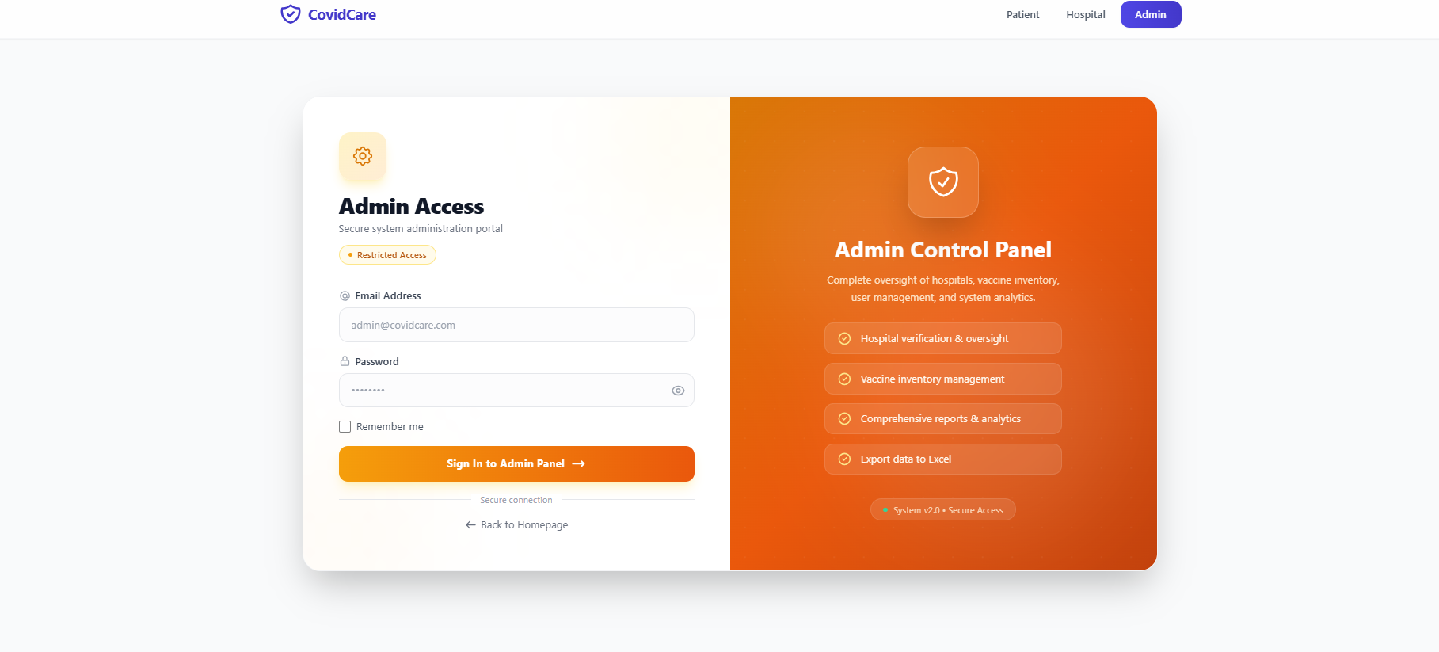

Admin Login Page
The Admin Login Page provides secure access to the administrative panel of the CovidCare system. It is designed exclusively for authorized administrators who are responsible for managing the overall platform, including hospitals, patients, vaccine inventory, and system reports. The page features a modern two-column layout consisting of a secure login form and an overview of the administrative functionalities.
The interface is clean, responsive, and designed to ensure secure authentication for system administrators.

Login Form
The left side of the page contains the Admin Login Form, where administrators enter their credentials to access the Admin Control Panel.
The form includes the following components:
- Email Address – Allows the administrator to enter the registered email address.
- Password – Allows the administrator to enter a secure password.
- Remember Me – Keeps the administrator logged in on the current device for future sessions.
- Sign In to Admin Panel – Authenticates the administrator's credentials and redirects them to the Admin Dashboard.
- Back to Homepage – Allows users to return to the website's homepage.
- Secure Connection – Indicates that the login process is protected through secure authentication.
- Restricted Access – Displays that only authorized administrators are permitted to access this portal.

Admin Control Panel Preview
The right side of the page provides a preview of the Admin Control Panel, highlighting the key responsibilities and features available after successful login.
The administrator can perform the following tasks:
- Verify and approve hospital registrations.
- Manage vaccine inventory and healthcare resources.
- Generate comprehensive reports and system analytics.
- Export reports and records to Excel for documentation and analysis.
- Monitor and manage the overall activities of the CovidCare platform.
This preview gives administrators a clear understanding of the system's management capabilities before accessing the dashboard.

User Interface Design
The Admin Login Page features a modern card-based layout with an orange gradient theme that distinguishes the administrative portal from the Patient and Hospital portals. Rounded components, responsive design, and clean typography create a professional interface that is optimized for desktop, tablet, and mobile devices.

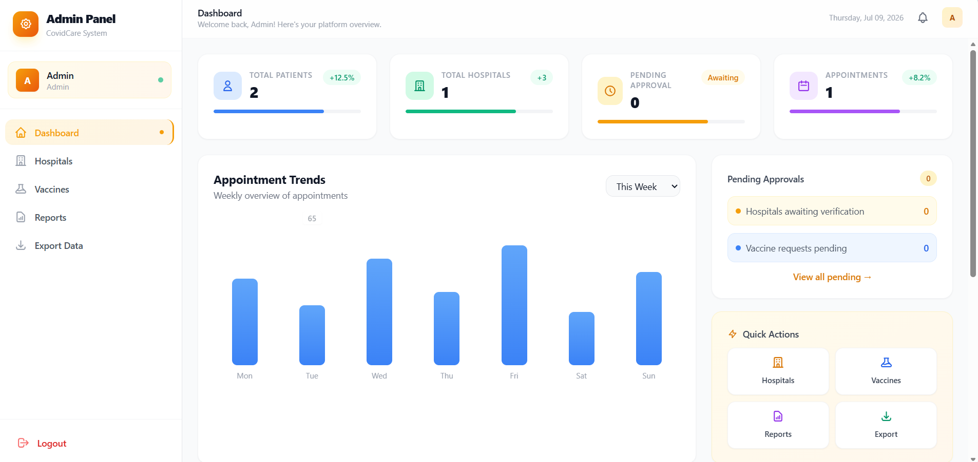

Admin Dashboard
The Admin Dashboard is the main control panel of the CovidCare system. It provides administrators with a complete overview of the platform, allowing them to monitor system activities, manage hospitals, oversee vaccination records, generate reports, and export important data. The dashboard is designed with a modern and user-friendly interface, enabling administrators to perform their tasks efficiently.

Dashboard Overview
The top section of the dashboard displays a welcome message along with the current date and notification icon. This provides administrators with quick access to notifications and an overview of the system whenever they log in.

Statistics Cards
The dashboard displays several summary cards that provide real-time information about the platform.

Total Patients
This card displays the total number of registered patients in the system. It helps administrators monitor patient registrations and overall platform usage.

Total Hospitals
This card shows the number of hospitals registered and approved on the platform. It enables administrators to track healthcare providers connected to the system.

Pending Approval
The Pending Approval card displays the number of hospitals or requests awaiting administrative verification. This allows administrators to quickly identify pending tasks that require approval.

Appointments
This card presents the total number of COVID-19 test and vaccination appointments booked through the platform. It provides a quick overview of healthcare service activity.

Appointment Trends
The Appointment Trends section displays a weekly bar chart representing the number of appointments scheduled each day.
This graphical representation helps administrators:
- Monitor appointment activity throughout the week.
- Identify peak and low appointment days.
- Analyze system performance and patient engagement.
- Support future planning and resource allocation.
The chart can also be filtered according to different time periods for better analysis.

Pending Approvals
The Pending Approvals panel provides a summary of tasks that require administrative action.
It includes:
- Hospitals awaiting verification.
- Pending vaccine-related requests.
- A quick link to view all pending requests.
This section helps administrators ensure that all pending approvals are handled promptly.

Quick Actions
The Quick Actions panel provides shortcut buttons for frequently used administrative tasks.
The administrator can quickly navigate to:
- Hospitals – Manage and verify registered hospitals.
- Vaccines – Manage vaccine inventory and vaccination records.
- Reports – Generate and view analytical reports.
- Export – Export system data to Excel for documentation and record keeping.
These shortcuts improve efficiency by reducing the number of navigation steps.

Sidebar Navigation
The left sidebar provides easy access to all administrative modules of the system.
The available menu options include:
- Dashboard
- Hospitals
- Vaccines
- Reports
- Export Data
- Logout
The sidebar allows administrators to switch between different modules quickly while maintaining a consistent navigation experience.
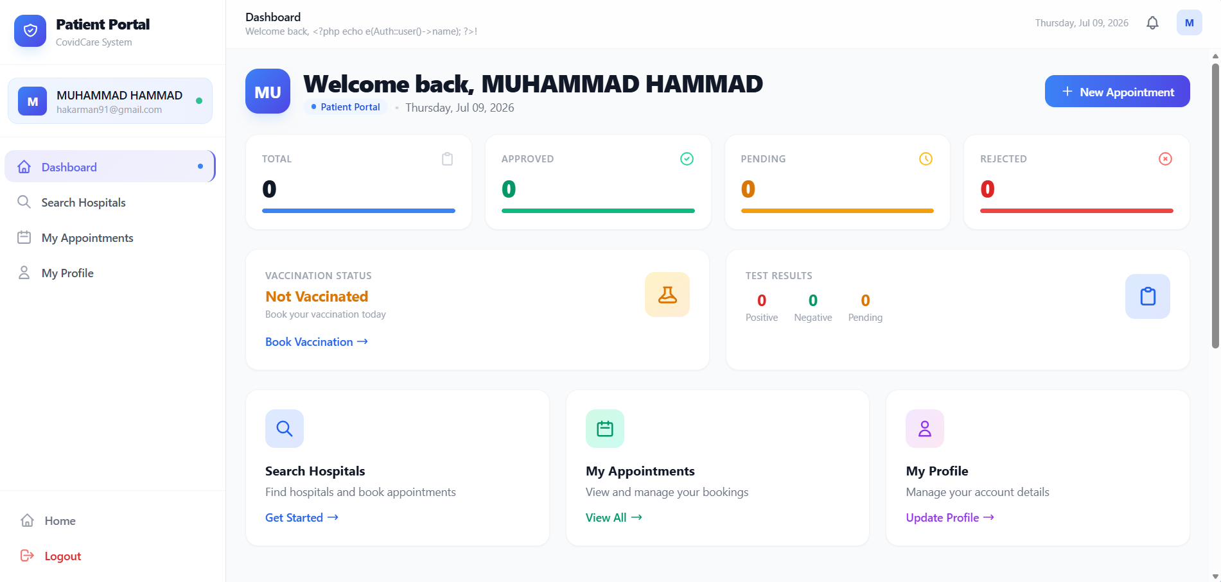Patient Dashboard
The Patient Dashboard is the main page that appears after a patient logs into the COVID Test and Vaccination Booking System. It provides a complete overview of the patient's appointments, vaccination status, and test results in one place.

1. Header Section
At the top of the dashboard, the patient is welcomed with a personalized greeting displaying their name. The current date, notification icon, and a "New Appointment" button are also available for quick access.

2. Patient Information Card
On the left sidebar, the patient's basic information is displayed, including:
- Profile avatar
- Full name
- Email address
- Online status
This allows the patient to quickly identify their logged-in account.

3. Navigation Menu
The sidebar provides easy navigation to different sections of the portal:
- Dashboard – Displays the overview of patient activities.
- Search Hospitals – Allows patients to search for hospitals and healthcare centers.
- My Appointments – Shows all booked COVID test and vaccination appointments.
- My Profile – Enables patients to view and update their personal information.
- Logout – Securely signs the patient out of the system.

4. Appointment Summary Cards
The dashboard contains four summary cards that display appointment statistics:
- Total – Shows the total number of appointments booked.
- Approved – Displays appointments approved by the hospital.
- Pending – Shows appointments waiting for approval.
- Rejected – Displays appointments that have been rejected.
These statistics help patients easily track the status of their bookings.

5. Vaccination Status
This section shows the patient's current vaccination status.
For example:
- Not Vaccinated
- Partially Vaccinated
- Fully Vaccinated
If the patient is not vaccinated, a "Book Vaccination" button is provided to schedule a vaccination appointment.

6. COVID Test Results
This panel displays the patient's COVID-19 test results, including:
- Positive Tests
- Negative Tests
- Pending Test Results
Patients can quickly monitor the outcome of their COVID tests.

7. Quick Action Cards
The dashboard also provides shortcut cards for frequently used features:
Search Hospitals
- Search nearby hospitals.
- View available healthcare facilities.
- Book appointments easily.
My Appointments
- View all appointment history.
- Check appointment status.
- Manage existing bookings.
My Profile
- Update personal details.
- Edit contact information.
- Manage account settings.

8. User-Friendly Interface
The dashboard is designed with a clean and responsive interface using modern UI components. Different colors are used to represent appointment statuses, making it easy for patients to understand their information at a glance.
==================================================================

Hospital Dashboard
The Hospital Dashboard is the main interface for hospital staff after they log into the COVID Test and Vaccination Booking System. It allows hospitals to manage patient appointment requests, monitor booking statistics, and respond to patients efficiently. The dashboard presents important information in a clear and organized layout, making daily operations easier.

1. Header Section
The top section displays:
- The hospital's name (Jinnah Postgraduate Medical Centre (JPMC)).
- A personalized welcome message.
- The current date.
- Notification icon.
- View All Requests button for quick access to all patient appointment requests.
This section helps hospital staff quickly access important functions.

2. Hospital Information Card
On the left sidebar, the hospital profile is displayed, including:
- Hospital logo/avatar
- Hospital name
- Email address
- Online status indicator
This confirms that the correct hospital account is currently logged in.

3. Navigation Menu
The sidebar contains the main navigation options:
- Dashboard – Displays an overview of hospital activities.
- Manage Requests – View and manage patient appointment requests.
- Home – Returns to the website homepage.
- Logout – Securely logs out of the hospital account.

4. Dashboard Statistics

Pending Requests
This card displays the number of patient appointment requests waiting for hospital approval.
For example:
- 0 Pending Requests
When patients submit appointment requests, this number automatically increases.

Total Appointments
This card shows the total number of appointments received by the hospital.
It helps hospital staff monitor their overall workload.

Quick Action
The Manage Requests card provides a shortcut that allows hospital staff to directly open the appointment management page without searching through the menu.

5. Appointment Request Section
The large center panel displays all incoming appointment requests submitted by patients.
For each request, hospital staff can:
- View patient information.
- Check appointment details.
- Review the requested date and service.
- Approve the appointment.
- Reject the appointment if necessary.
In the current dashboard, no patient has submitted a request yet, so the message "No requests yet" is displayed.

6. System Status
At the bottom of the dashboard, a system status message is shown:
- System running smoothly
- All data is up to date
This indicates that the application is functioning correctly.

Main Purpose of the Hospital Dashboard
The Hospital Dashboard enables hospitals to:
- Receive patient appointment requests.
- Monitor pending and total appointments.
- Approve or reject appointment requests.
- Manage patient bookings efficiently.
- Keep hospital staff informed through real-time statistics.
==============================================================================
Search Hospitals Page
The Search Hospitals page allows patients to search for approved hospitals where they can book COVID-19 test or vaccination appointments. It provides a simple and user-friendly interface to quickly find healthcare facilities based on the hospital name or location.

1. Page Header
At the top of the page, the title "Search Hospitals" is displayed along with a short description:
"Find approved healthcare facilities near you."
This informs the patient about the purpose of the page.

2. Search Bar
The main feature of this page is the search section.
Patients can:
- Enter the hospital name.
- Enter a city or location.
- Click the Search button to find matching hospitals.
This makes it easy to locate hospitals that provide COVID-19 testing and vaccination services.

3. Search Results Area
The large content area below the search bar is reserved for displaying hospital search results.
After searching, each hospital card can display information such as:
- Hospital Name
- Address
- Contact Number
- Available Services (COVID Test / Vaccination)
- Appointment Booking Button
Patients can select a hospital and proceed with booking an appointment.

4. Empty State
When no search has been performed, or no hospital matches the search criteria, the page displays the message:
"Find a hospital"
with the instruction:
"Enter a hospital name or location above to search for approved healthcare facilities near you."
This guides the patient on how to use the search feature.

5. Sidebar Navigation
The left sidebar provides quick access to other patient features:
- Dashboard – View an overview of patient activities.
- Search Hospitals – Search for approved hospitals.
- My Appointments – View booked appointments and their status.
- My Profile – Manage personal information.
- Home – Return to the website homepage.
- Logout – Securely sign out of the patient account.

6. Purpose of the Search Hospitals Page
The main purpose of this page is to help patients:
- Find approved hospitals.
- Search hospitals by name or location.
- View hospital details.
- Select a suitable healthcare facility.
- Book COVID-19 test or vaccination appointments easily.
==============================================================================
END

